**CN4003- Web Technology**

**Week-1-31/1-06/02/22**

**Activity1.1: Drag the words into the correct boxes according to the slides:**- Plan to study four hours a week.

-The assignment will be released on week 2.

-Take advantage of the formative feedback.

-Always try to finish assignment two days early.

-Write down questions and put these to your lab tutors.

-Only if your questions are not resolved, email to the module leader*.

**Activity 1.2: What do you use the web for?**

* –Buying

Correct answer.

* –Selling

Correct answer.

* –News

Correct answer.

* –Watching Videos, TV, and Movies

Correct answer.

* –Social Media (Socialising)

Correct answer.

* –Listening to Podcast and Radio

Correct answer.

* –Banking

Correct answer.

* – Medical Advice

Correct answer.

* –Playing Games

Correct answer.

* –Studying

**Activity 1.3: Identify the correct definitions for the following terms:**

**Drag the words into the correct boxes**

Extranet

 private computer network, extends Intranet by allowing access to partners, vendors and suppliers or an authorized set of customers.

URL

 It is a web address.

HTTP

 Rules of communication (Protocols) for finding a page on WWW.

Hypertext

 is text displayed on a computer display or other electronic devices with references to other text that the reader can immediately access.

Hyperlink

 simply a link, is a reference to data that the user can follow by clicking or tapping.  
Hypermedia.

HTTPS

 Rules of communication (Protocols) for finding a page on WWW but encrypted.

FTP

 Rules of communication (Protocols) for sending files online.

Internet Browser

 is a software application for accessing information on the World Wide Web.

Intranet

 is a computer network within an organization, usually to the exclusion of access by outsiders.

**Activity 1.4:**

What is the key difference between static and dynamic website?

* - Coding
* - Layout
* - Use of a database

Correct answer.

* - Security measures
* - Design

**Week one Lab Practice:**

**1. Q. In one sentence and using your own words: What is the internet?**

A. The internet is a comprehensive group of networks that facilitates personal and commercial communication.

**2. Q. In no more than three sentences and using your own words: How does the internet work?**

A. The internet works by using a packet routing network. It follows IP which is Internet protocol and TCP which is Transport Control Protocol.

**3. Q. Briefly explain, how did the internet start? Remember the drawing of the map from the lecture.**

Sputnik, the first man-made satellite, was launched in 1957 by the Soviet Union. The revelation came as a shock to Americans. The cold war was at its height, and the US and the Soviet Union were considered adversaries.

The Advanced Research Project Agency (ARPA) in 1958 by President Dwight D. Eisenhower in reaction to the launch of Sputnik. The goal of ARPA was to give the US a technological advantage over the nations. Computer Science was a crucial component of ARPAs mission. Computers were massive machines in the 1950s, taking up entire rooms. They lacked the processing power and memory of today’s computers. Many computers could only read magnetic tape or punch cards and there was no means to connect them via a network.

ARPA set out to change this. To build a computer network, it enlisted the service of (Bolt, Beranek and Newman) BBN. Four computers with four different operating systems have to be connected across the network. ARPANET was the name given to the network.

Although other groups were working on ways to network computers, ARPANET established the protocols used on the Internet today.

Engineers began looking for a mechanism to connect ARPANET to the packed radio network 1973. (PRNET) A Packet Radio Network uses radio transmitters and receivers to connect computers. The computers use radio waves instead of phone wires to transfer data. Engineers finally joined two networks in 1976 after three years of labor. In 1977, technicians connected the Satellite Network (SANET) to the two other networks. Inter-networking or the Internet for short was the name given to the connecting of different networks.

**4. Q. In one sentence and using your own words: What is an internet service provider (ISP)?**

A. An **ISP (Internet Service Provider**) is a company that provides Internet access to business and individuals

**5.Q. In one sentence and using your own words: What do you mean by URL?**

A. The **URL (Uniform Resources Locator)** is a standard for locating Web resources.

**6. Q. In one sentence and using your own words: What is a Domain Name? Give an example.**

**A.** The domain name is a component of a uniform resource locator (URL) that is used to access website.

Example: bt.com

**7. Q. Briefly and using your own words: what is an IP Address? Why is it important?**

1. Ip address is a unique string of characters that identifies each computer using the Internet Protocol to communicate over a network.

Importance of IP Address:

IP address is as much important as a person’s unique identification card or number.

**8. Q. In one sentence and using your own words: What is the World Wide Web?**

A. World Wide Web is an internet-based information system that allows papers to be linked to one another via hypertext links, allowing the user to search for information by navigating from one document to the next.

**9.Q. In one sentence and using your own words: What is a Web Browser?**

**A.** A web browser is an application used to access and view websites.

**10. Q. In one sentence and using your own words: What is HTTP? What do we use it for?**

**A.** HTTP (Hypertext Transfer Protocol) is a protocol for fetching resources such as HTML documents and it is used for transferring data from a web server to a browser to view web pages.

**11. Q. In two sentences and using your own words: What is FTP? What do we use it for?**

**A.** FTP is a widely used oldest network protocol for transferring files between computers over a TCP/IP-based network, such as the Internet.

FTP lets people and applications exchange and shares data within their offices and across the Internet.

**12. Q. In one sentence and using your own words: What is an Anchor in Web Design?**

**A.** An anchor is a web page element that links to another location on the same page.

**13. Q. In one sentence and using your own words: What is the use of Forms in HTML?**

**A.** An HTML form is part of a web page that can accept users’ input and forms are used for, feedback collection, searching databases, submitting details, and making e-commerce orders.

**14. Q. Briefly and using your own words: How do we use Session Management and Cookies in Web Design?**

**A.** The session is usually used to identify a user. If one user is login into any dynamic website. Data will display based on the user’s profile.

If another user is also login into the same website, then that user will get data according to his profile.

A cookie is a small piece or chunk of the memory for a specific browser. That piece is a simple text (a unique key) that is used to exchange the information between browser and server.

Cookies are generally used to personalize the web experience because they keep track of the performance of the user. When a user visits any website, the site sends the data packets to the user’s computer in a form of a cookie.

**15. Q. In one sentence and using your own words: What is the Scripting in HTML?**

**A.** In HTML, a script is a small, embedded program that can add interactivity to your website. For example, a script could generate a pop-up alert box message, or provide a dropdown menu.

**16.Q. In one sentence and using your own words: What is the difference between client-side and server-side scripting?**

## **A.** **Difference Between Server-Side Scripting and Client-Side Scripting**

|  |  |  |
| --- | --- | --- |
| **Parameters** | **Server-Side Scripting** | **Client-Side Scripting** |
| Script Running | For server-side scripting, a web server serves as the medium for running it. They create the pages that one would send to the browser. | The script for the client-side scripting runs by using a browser. It is present already in any user’s computer. |
| Uses | We use the server-side scripting at the back-end, where the source code stays hidden from the browser (client-side)- making it non-viewable. | We use the client-side scripting at the front end, and any user can view it using the browser itself. |
| Occurrence | Server-side scripting occurs whenever a browser initiates a request for it. As a result, many dynamic pages get created on the basis of several conditions. | Client-side scripting occurs when all the codes that a browser possesses in a page later change/ alter according to any user’s input. |
| Operation | Any server is capable of carrying out server-side scripting, but it can’t carry out client-side scripting. | A typical browser performs the client-side scripting after it receives a page (that the server sends). |
| Execution | The server-side scripting occurs on a remote computer. Thus, the response we get is slower as compared to that of the client-side scripting. | The client-side scripting occurs on the local computers. Thus, in this case, we get a comparatively quicker response in comparison with the server-side scripting. |
| Suitability | The server-side scripting works well for the areas that require the loading of a dynamic type of data and information. | The client-side scripting works well in those cases that require user interaction. |
| Connection to the Server Database | The server-side scripting assists a user in connecting to the database that already exists in the concerned web server. | The client-side server doesn’t connect to those databases that exist primarily on the concerned web server. |
| Access To Various Files | The server-side scripting has complete access to all the files present in any web server. | The client-side scripting has no access to the files that exist in a web server. |
| Languages | Languages like Ruby on Rails, Perl, ASP, Python, ColdFusion, PHP, etc., come into play in the case of server-side scripting. | Languages like VB Script, CSS, HTML, Javascript, etc., are very common in the case of client-side scripting. |
| Security | The server-side scripting is way more secure as compared to the client-side one. It is because the scripts of the server-side stay hidden from any random clients. | The client-side scripts are much less secure as compared to the server-side ones. It is because these scripts don’t stay hidden from any random client’s end. |

**17. Q. In one sentence and using your own words: What is an Applet?**

**A.** An applet (little application) is a small software program that supports a larger application program.

**18. Q. Briefly and using your own words: How do we use web animation? Do you like it?**

**A.** We can add animation to a web page by using DOM ( Document Object Model) and setting customized properties.

Yes I like it.

**19. Q. Briefly and using your own words: What is the difference between static and dynamic pages?**

## **A.** **Difference Between Static Web Pages and Dynamic Web Pages**

|  |  |  |
| --- | --- | --- |
| **Parameter** | **Static Web Pages** | **Dynamic Web Pages** |
| Basics | The content on web pages remains the same unless someone physically makes any changes on its hard disk (manual alterations). | This type of web page is behavioral. The content of pages is capable of differing for different visitors. It keeps changing with time and other parameters. |
| Definition | A static web page is a simple HTML written page that serves as a type of direct response from a browser to the server. All the data and info remains static in nature, and it stays the same unless someone manually makes any changes to it. | A dynamic web page is a type of page written in complex languages like AJAX, ASP.NET, etc. The data here gets rendered to some capacity and interpretation for producing varied content for different users visiting the page at different times. |
| Complexity | These types of web pages are very simple. The data in these pages remain static and require no interpretation before the process of rendering. Thus, it comes with no complexity. | These types of web pages are complicated. They go through the process of interpretation- making the data dynamic in nature. Due to this, such pages become way more complex as compared to any static web pages. |
| Frequency of Information Change | Content and information rarely change on a static web page. | The content and information change frequently on a dynamic web page. |
| Loading Time | These web pages take a very short time to load as compared to the dynamic ones. It is because they contain very static data and info on the pages. | These web pages take longer to load as compared to the static ones. It is because of the more complex, dynamic data present in these web pages. |
| Use of Database | The static web pages generally do not use databases. They do not require data redecoration very often. | The dynamic web pages use databases because it involves frequent data and info redecoration. |
| Languages Used | Languages like CSS, JavaScript, HTML, etc., come into play when writing static web pages. It uses only simple languages. | Languages like ASP.NET, ASP, AJAX, CGI, etc., come into play when writing dynamic web pages. It requires some very complex languages for a stable operation. |
| Application Program | These do not contain any application programs. | These contain application programs for various services. |
| Work Required | Less work and complexity go into designing static web pages. | More work and complexity go into designing dynamic web pages. |
| Cost of Development | Designing static web pages requires very low cost as compared to dynamic ones. | Designing dynamic web pages is more costly as compared to static ones. |
| Rendered Data | The data in static web pages don’t change automatically. One needs to manually make necessary changes on it- making it static in nature. | The data and info in dynamic web pages first stay interoperate at the server-side. Due to this, the data doesn’t remain similar on each call- making the data contained in it dynamic in nature. |

**20. Q. Briefly and using your own words: What is a database-driven web page? And when will you learn about them?**

**A.** A database-driven website is a website that has most of its content in a database.

**Week-2-07/02-13/02/22:**

**Activity 2.1: Downloading Notepad in the device.**

**Done**

**Activity 2.2: What are the meanings of these tags and attributes?**

Drag the words into the correct boxes

* <h2>This tag helps create a heading, level 2
* <br>This tag helps create break on a page.
* <blockquote>This tag helps create an indentation and block text.
* <u>This tag underlines the text.
* <p>This tag will create a new paragraph.
* <b>This tag will make the text bold, also known as 'Strong'.
* <i>This tag will make the text italic, also known as 'emphasis'.
* <a>This tag will help create a hyperlink.
* HREF This is an attribute that stands for Hyper-Reference.

**Activity-2.3: Drag the words into the correct boxes**

**Edit the following <IMG> codes to reflect the location of the image which has SRC= “MyPic.JPG**”.  
  
Image is inside folder called ‘Images’ which is on the same folder as your HTML page.

**Correct answer:**

**<IMG SRC="Images/MyPic.JPG", border="1", Height="150", Width="125", Alt="My Image">**

Image is on the same folder.

**Correct answer:**

**<IMG SRC="MyPic.JPG", border="1", Height="150", Width="125", Alt="My Image">**

Image is on inside folder called ‘Pictures’ which is on the same folder as your HTML page.

<IMG SRC=” Pictures/MyPic.JPG”, border=”1”, Height=”150”. Width=”125”, Alt=” My Image”>

Image is in a different folder on the C drive ‘C:/This PC/Pictures’.

<IMG SRC="C

**Activity-2.4: Which one of these statements are correct explanation of the code?**

**Tick the correct answers.**

* **p {font-family: ‘Arial'; font-size:12px;color:green;}** This will turn paragraph with font that is 'Arial' and font heading 12, and font colour green.
* **a: link {color:blue;}** **a:visited {colorogenic;}** This will create a hyperlink that is Blue and when you vist the website turns Green.
* Correct answer.
* **a:link {color:blue;}** **a:visited {color:green;}** This will create a hover hyperlink that is Blue when you hover over it and when you vist the website turns Green.
* **h1 {background-color:Yellow; text-align:left;}**
* This will change the background of the page to Yellow and align all the text as left.
* **h1 {background-color:Yellow; text-align:left;}**
* This will change the heading 1 of the page to Yellow and align all the text as left.
* Correct answer.
* **p {font-family:'Arial'; font-size:12px;color:green;}** This will turn paragraph with font that is 'Arial' and font size 12 pixels, and font colour green.
* Correct answer.
* **h1 {background-color:Yellow; text-align:left;}**
* This will change the paragraph of the page to Yellow and align all the text as left.
* **a:link {color:blue;}** **a:visited {color:green;}** This will create a hyperlink that is Green and when you vist the website turns Blue.
* **p {font-family:'Arial'; font-size:12px;color:green;}** This will turn paragraph with font that is 'Arial' and font size 12 cms, and font colour green.

**Activity 2.5: What are the three ways to connect a CSS file to page? Which one is recommended for us to use?**

**Drag the words into the correct boxes**

**For each of the examples of CSS, indicate what type it is:**

In-line CSS Style...

 <H1 STYLE= “color: green; font-size: 25px;”>A large Green Heading</H1>

CSS File linked t...

 <LINK REL=“stylesheet” TYPE=“text/css” HREF=“styles/mystyles.css”/>

Embedded CSS codes

<HEAD>  
<STYLE TYPE= “text/css”>  
H1 {color: green;}  
P {font-size: 14pt; color: blue;}  
</STYLE>  
</HEAD>  
  
Which statement is correct:  
W3C recommends you use separate CSS file connected to the page:

Correct

W3C recommends you use embedded CSS file connected to the page:

Incorrect

**Lab Practice:**

**Note**: Created first page using CSS and html codes below. Here is three separate files- CSS Textstyle and Myfirstpage.html-Notepad. Can make changes with this code anything wants.

Replace your docs with Mr Fadis doc. Exmple, photo, background etc,

**Codes for text style:**

**body{background-image:url('cox-1.JFIF');**

**background-repeat: no-repeat;**

**background-size: 1920px 1080px;**

**} /* This adds the background to the pages */**

**Code for the first page**

**<!doctype html>**

**<!-- This is a demo page created for Web Design Module. Copyright Dr Fadi Safieddine 2021 -->**

**<html lang="en"> <!-- This tag is specify the language on this page is English, only by default this can be assumed the case with HTML -->**

**<head>**

**<Title>MyFirst Test Page</Title>**

**<link rel="stylesheet" type="text/css" href="textstyle.CSS" /> <!-- The CSS link -->**

**</head>**

**<body>**

**<h1> Welcome to My Very First Web Page Design in HTML</h1>**

**<blockquote>**

**This is the lab 2 practice of </STRONG>CN4003 to built Web Design Page. </STRONG>**

**I have to read <EM> HTML 5 </EM> from books in the library and I have to remember to <U>**

**read the lecture slides before come to the Q & A session and the lab session. </U>**

**</blockquote>**

**<P> To get slides, I need to go to <A HREF =http://www.uel.ac.uk> our UEL website </A>.**

**However if I get stuck I can always <A HREF = mailto:fadi@uel.ac.uk> email</A>**

**my tutor.**

**</P>**

**<p>**

**<img SRC="me.jpg", border="1", Height="300", Width="300", Alt="Tutor's image">**

**</p>**

**</body>**

**</html>**

**h1 {background-color:Gold; text-align:Center;} /* Headings declared as H1 will be centered and Green */**

**p {font-family:'Arial'; font-size:14px;color:blue;} /* Paragraphs set as Arial, 14px, and Blue */**

**a:link {color:red;} /* Hyperlinks to be given Red color when not visited */**

**a:visited {color:green;} /* Hyperlinks to turn green once they are visited */**

**Week-3-14/02-20/02/22**

**Lab-3 Practical:**

**Code for adding……**

**Week-6:**

**07/03/-13/03/22**

**Activity 6.1. Looking at the three images below and the three different possible DPI settings, can you guess which one is which? 30DPI, 120DPI, 300DPI**

Drag the words into the correct boxes

Image A is likely to be

120 DPI

Image B is likely to be

30 DPI

Image C is likely to be

Activity 6.2. Assign best practice associated with each image format as discussed in the lesson:

Drag the words into the correct boxes

Which one is best for low storage while maintaining good quality as Web images:

JPG

Which one is best for low quality animation:

GIF

Which one is best for high quality printing:

PNG

Activity 8.1.

What is the difference between client-side scripting and server-side scripting? (Select the true statements)

Server side scripting process logins and credit card transactions.

Correct answer.

Client side scripting can process login and credit card transitions.

Client side scripting runs on home computer.

Correct answer.

Server side scripting runs on the computer but also connects to the server.

Activity 8.1. Why is copy/paste wrong when you have done the research yourself anyway?

* –All of the above.

Correct answer.

* –It does not tell us you understood the topic, it just tells us you know how to copy/paste.
* –Because it is claiming something to be written by you when it is in fact written by someone else.
* –Because it is a form of cheating.

**Activity 8.2. Which one of these is a reference and one is a citation of a source.**

Drag the words into the correct boxes

“Client scripts are interpreted by the client-browser and are tightly coupled with HTML/ASP inside the browser. ”(Negrino and Dori, 2001, p. 7). - This is the

Citation

Negrino, Tom and Smith, Dori (2001) JavaScripts: For the World Wide Web. 4th ed. Berkely: Peachpit Press.

This is the end o...

**Activity 9.1. Try these codes and tell us what they generate:**

Case 1: Run the programme

var x = 1;

do {

X = X + 1

document.write(“I can do JavaScript!"); document.write("</BR>");

} while ( P <=10);

Case 2: Student gets overall 70% but one of the individual assessment 35%.

if (Overall >= 50) && (Individual >= 40)

{document.write(‘You passed.’);}

Else

{document.write(‘You did not pass.’);}

* Case 1: it will print "I can do JavaScript 10 times and Case 2: Print "You did not pass".

Correct answer.

* Case 1: it will print "I can do JavaScript 9 times and Case 2: Print "You did not pass".
* Case 1: it will print "I can do JavaScript 10 times and Case 2: Print "You did pass".
* Case 1: it will print "I can do JavaScript 9 times and Case 2: Print "You did pass".

Activity 10.1. First step in any web or app design is ‘Planning and Requirement Analysis’ which means:

* –Understanding how we will make money from the website.
* –Understanding what the purpose of the website.
* –All of the above.

Correct answer.

* - Understanding the users of the websites

Activity 10.1. First step in any web or app design is ‘Planning and Requirement Analysis’ which means:

* - Understanding the users of the websites
* –All of the above.

Correct answer.

* –Understanding how we will make money from the website.
* –Understanding what the purpose of the website.

Activity 10.2. Part of the Design Process, organise these steps in the ‘logical’ order:

Drag the words into the correct boxes

1. Wireframe

2. Image layout and size

3. Grouping of images

4. Colour codes

5. Menus

6. Navigation design

7. Agreed design signed

Activity 10.3. What is the name of the website we recommended to test the codes of your page:

* –Validator.W3.org

Correct answer.

* –W3Schools.com
* –Authenticate.info
* –All of the above
* –Notepad++.com

Activity 10.4. True or false: Process of web design is a continuous process as website regularly require improvements.

True

False

Activity 11.1. Your checklist for the final submission (how well will you do?)

* I have engaged with the module and answered nearly all the activities

Correct answer.

* I have completed the Case study (Task 1).

Correct answer.

* I have completed the website reseach of 10 web pages (task2)

Correct answer.

* I have completed web planning, including create navigational, layout, and color theme planning (Task 3)

Correct answer.

* I have recieved feedback on my website from my tutor and they said it is satisfactory or better.

Correct answer.

* I have recieved feedback on my website from my tutor and they said it outstanding

Correct answer.

* I have engaged with the module, watched the lectures.

Correct answer.

* I have completed the building of my website.

Correct answer.

* I have engaged with the module and engaged in submitting all the lab practice.

Correct answer.

* I have received formative feedback on my website reseach of 10 web pages (task2)

Correct answer.

* I have recieved formative feedback on my web planning, including create navigational, layout, and color theme planning (Task 3)

Correct answer.

* I have received formative feedback on my Case Study (Task1)

Correct answer.

**Well done. You have engaged very well with the module. You have a good chance of getting distinction. Just complete your work to the great standard you have done so far!**

**Homepage:**

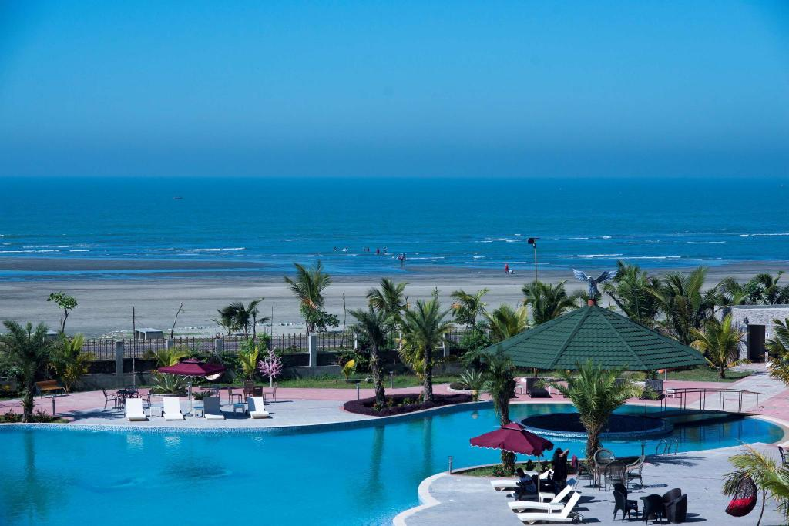

*“JOBS FILL YOUR POCKET BUT ADVENTURES FILL YOUR SOUL”*

<center> <h3> Cox's Bazar</p></h3>

<p><h3> The Tourist Capital of Bangladesh </h3></p>

<p><h3> World's Most Famous and Longest Natural Sandy Sea Beach! </h3></p>

Cox's Bazar is the world's largest unbroken sea beach in the Chittagong division. It is 120 km long slopping gently down to the blue water of the Bay of Bengal. It is one of the most attractive tourist spots in the world. Miles of golden sands, towering cliffs surfing waves roar conch shells, colorful pagoda, Buddhist temples, and the tribal people, delightful sea food are the attractions of Cox's Bazar. Many people tell it is the tourist capital of Bangladesh. The sea beach is comfortable for bathing and swimming.

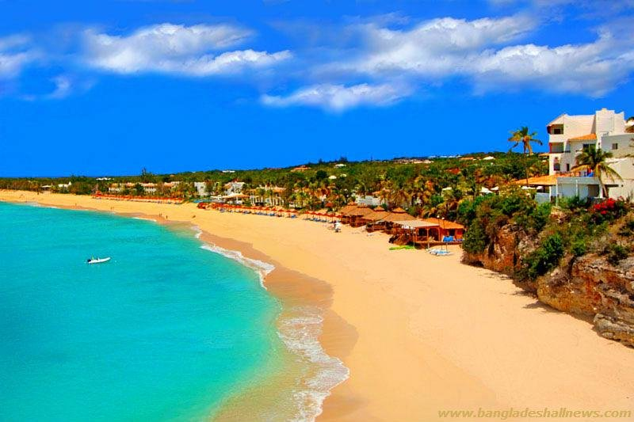

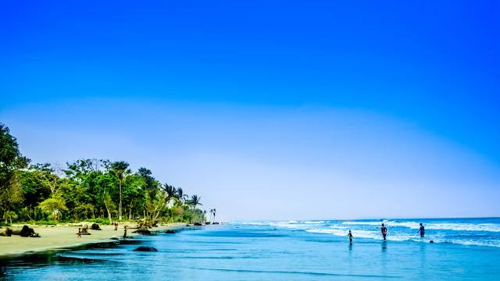

**Parts of the Beach:**

**Kolatoli Point:**

When the beach is calling your name, you might want to head down to **kolatoli Beach**-one of the most popular seaside in **Coxs Bazar**.

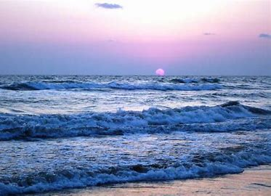

**Sugondha Point:**

Sugandha Point is situated north of Kolatoli point. There is a Burmese Market that is famous in Cox's Bazar. A trip to Cox’s Bazar almost remains incomplete if you don’t pay a visit to the famous Burmese market. A quick visit to the Burmese market will make your beach trip more exciting. Whether you want to collect beach glass or watch the sunset, **Sugondha Beach is one of the most popular seaside spots in Coxesbazar.**



Products in the Burmese Market

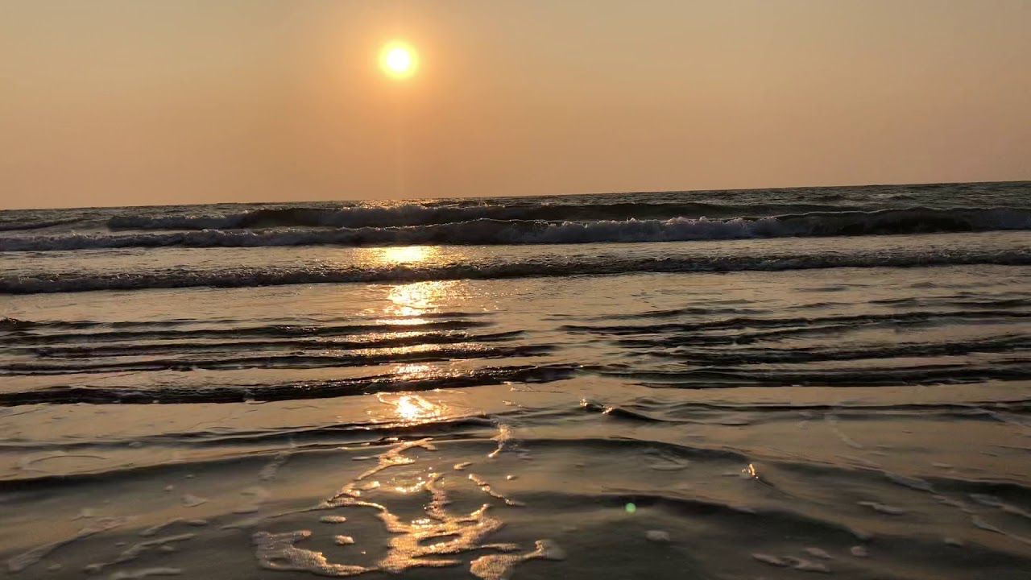

**Laboni Point:**

Laboni point is another famous part of the beach. People mainly gather mostly here. This part is best for horse riding, and speedboat riding.If you cannot wait to get to the beach, you might enjoy a trip to **Laboni Beach**, located 3.5 miles (5.7KM) from central **Cox`sbazar.**

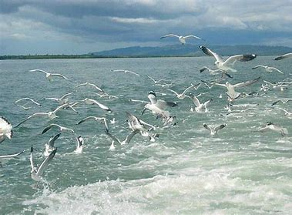

**Darianagar Beach:**

Darianagar is a place near in Himchori, Coxs Bazar, there is a cave worth visiting, also you can view the sunset from the top. If one is into trekking and stuff, it’s like a jungle park with chalets and hills where the sunset over the bay of Bengal can be observed.

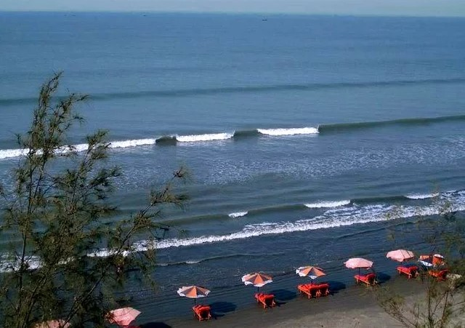

**Inani Beach**

Inani Beach is an 18-kilometer-long (11-miles) sea beach in Coxes Bazar. It has a lot of coral stones, which are very sharp. These coral stones look black and green, and they are found in the summ 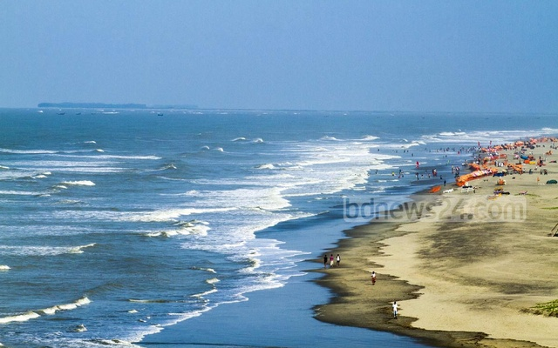er or rainy seasons.

**Technaf Beach**

Teknaf Beach is unlike of main part of the beach. Teknaf beach is wilder than main beach and surrounded by Teknaf peninsula mangrove. This section is divided by many beaches. Other beaches of the section are: Shamlapur Beach or Baharchara Beach, Shilakhali Beach Hajampara Beach and Shapuree Island Beach.

**Marin Drive**

A clean and tranquil road beside the Bay of Bengal will give you immense pleasure.

Beautiful hill and beachside drive. A clear and majestic view of the beach below and the ocean. Amazing place for sunset lovers.

The road is smooth as silk and extremely secure with Army and police checkpoints every few miles.

Roofless bus service is launched for the tourists to give them an amazing marine drive experience.

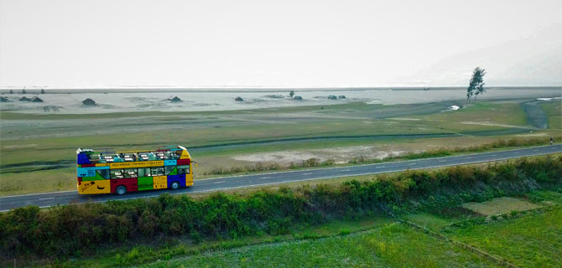

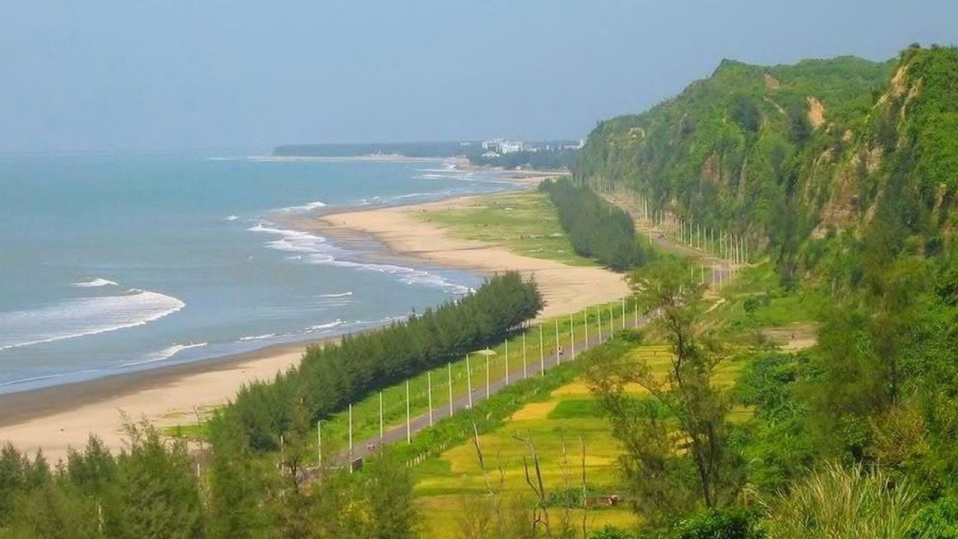

**Himchori Waterfall:**

**Himchori Waterfall** is 2.9 mile (4.7 km) from central **Cox`sbazar**, why not stop by during your stay! You can go to the Himchori hill and take shower in the waterfall. The waterfall looks very charming in the rainy season; you can also climb the hill to see an outstanding view of the sea. It feels heavenly to see how the sea meets with the hill.



**St. Martin Island:**

If you are a big fan of underwater lives and fishes, there is good news for you. You can go scuba diving in Saint Martin with experts to have an outstanding experience.

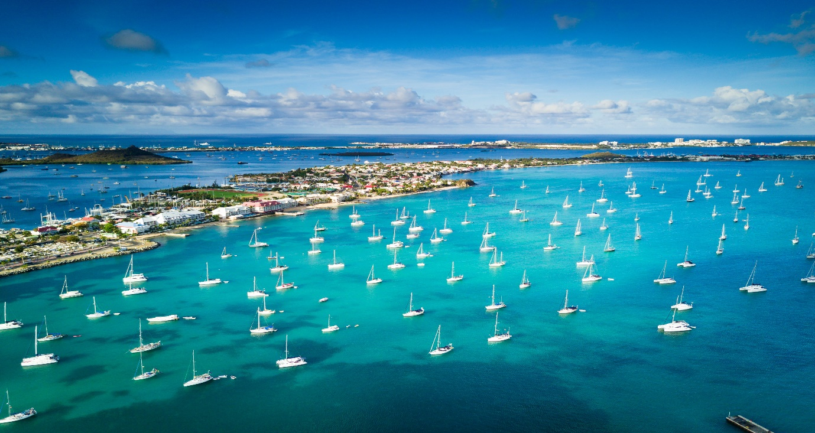

**Activities:**

**Rent a Bike and Have a Hassle-Free Tour:**

You can just rent the scooty & ride the whole day. You need to have a Driving License, keep security money & some regular documents.

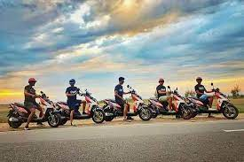

**Horse Riding:**

Horse riding on the beach has long attracted tourists to Cox's Bazar. Going to the sea beach is almost incomplete for many without a horse ride.

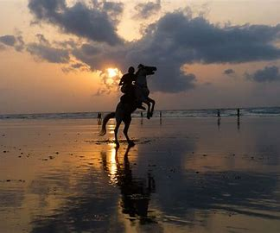

**Wind Surfing:**

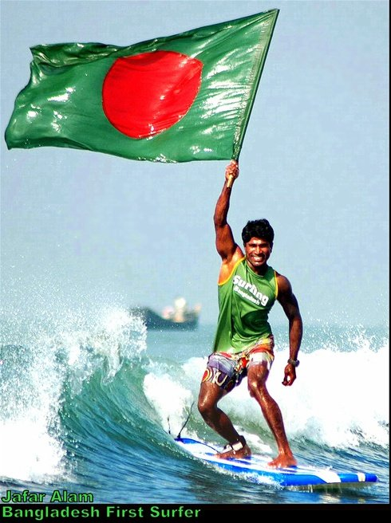

**Parasailing:**

If you love adventure, then you are going to love the parasailing there. Some professional trainers and guides are going to help you to do that. It is quite popular nowadays.

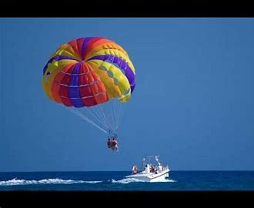

**Kayaking**

Cox Kayaking is an Adventure Kayaking activity first time in Cox's Bazar.

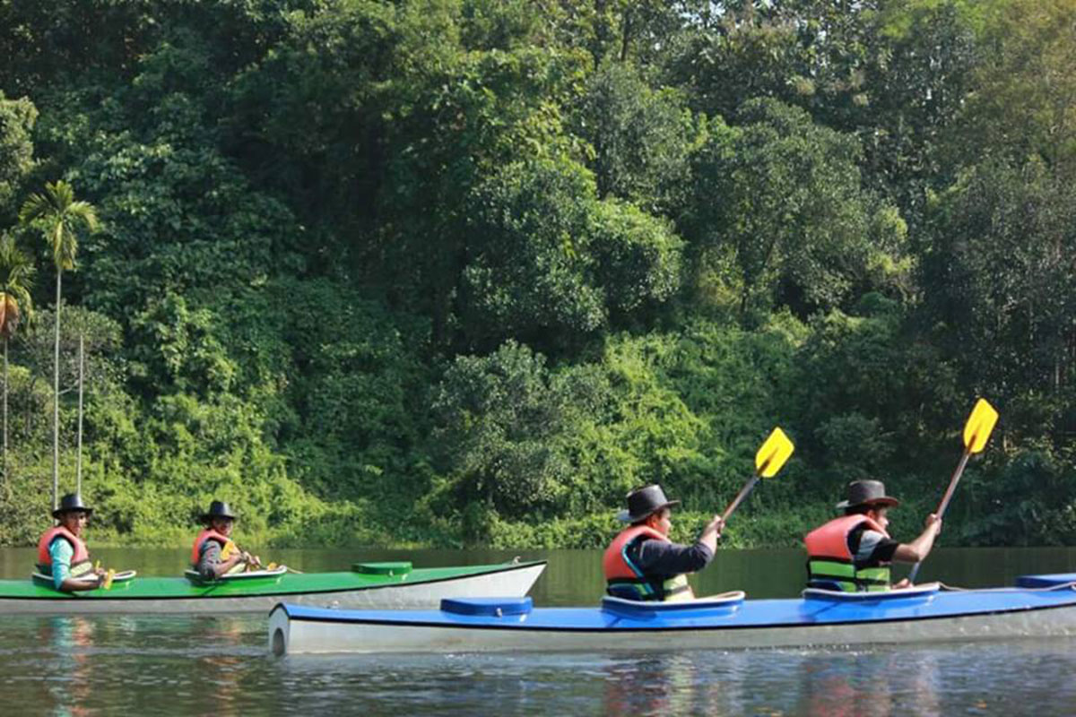

**Jet Ski**

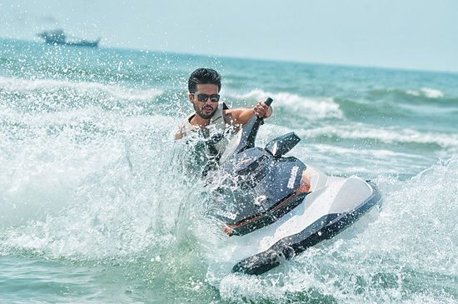

**Banana Boat**

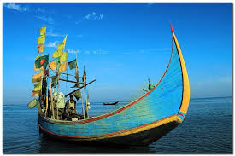

**Football & Volleyball:**

The three-day-long football and National Beach Volleyball tournament is a regular part of the beach activity arranged by local authorities every year. Whenever you visit Coxes Bazar you can play football and volleyball on the beach.



**Fly Dining Cox's Bazar:**

If you are looking for an exceptional dining experience, which will have you elated, quite literally, then Fly Dining is tailor-made for you! A unique concept 20-seat capacity Fly Dining will enable you and your loved ones to eat, drink and be merry at the height of 50 meters above ground level and to remember.

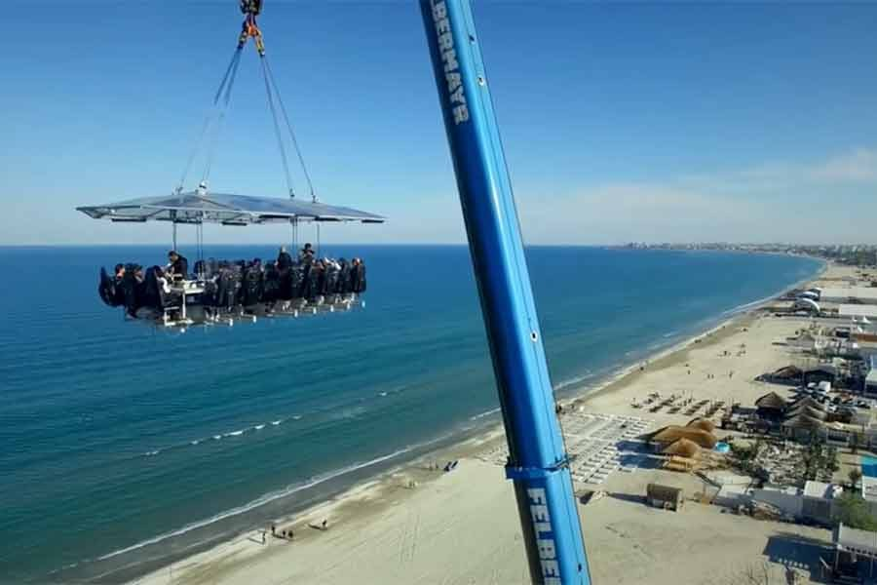

**Accommodations:**

There are several 3 stars and 5-star hotels that provide the exclusive beachside area with accessories for the tourist. Most of the hotels are around the sea beach and you can stay in a sea view hotel room and swim in an infinity pool of the resorts.

**Mermaid Beach Resort**

Mermaid beach resort is situated between Cox’s Bazar main town and Inani beach. It is a luxurious sea-faced resort. It has its well-decorated beach, and the rooftop view is also awesome.

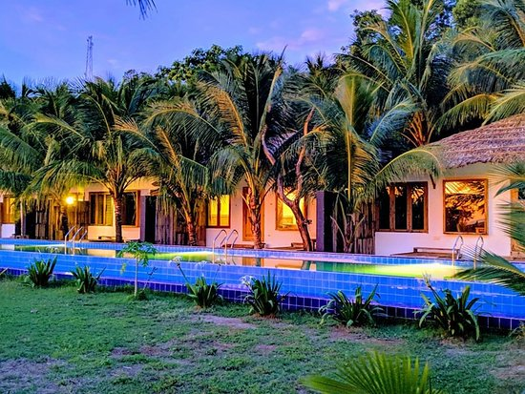

**Seagull Hotel:**

Enjoying an unrivaled location, overlooking the Bay of Bengal only 25 yards from the Bay water and sitting in the laps of hills, offer deluxe accommodation in 181 well-appointed guest rooms and suites. The panoramic view of the ocean, the majestic hills, and the natural beauty of the tamarind trees are all wonderfully complemented by luxury facilities and Bangladeshi hospitality.

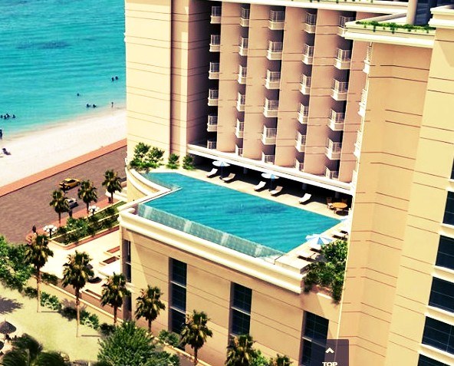

**Sea Pearl Beach Resort:**

Located on the world's longest undivided coastline - Cox's Bazar. Largest Eco Resort located on Inani Beach - Excellent coral viewing. All rooms have a sea view with a choice of balconies and kitchenettes Multiple Food & Beverage outlets serving local and international flavour’s Kids water park, Ice Cream Parlour, Gaming Parlour, Mocktail Bar Parasailing, Snorkelling, Speed Boat, Virtual Golf are available.

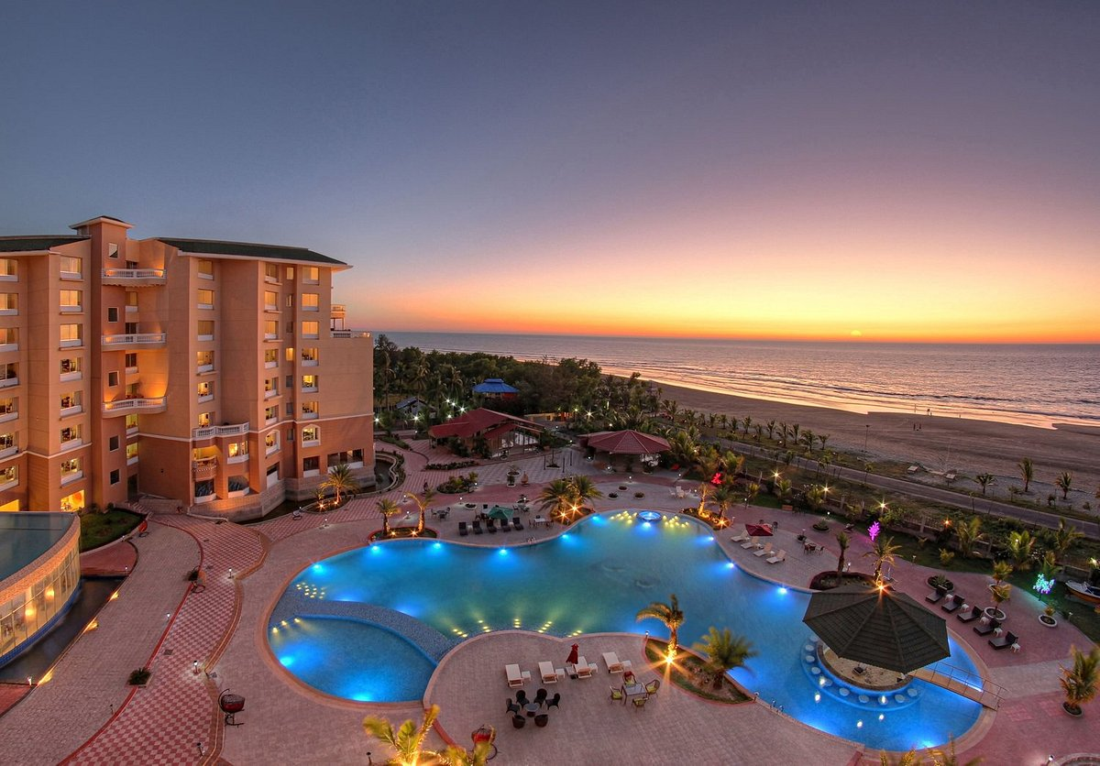

**White Orchid:**

White Orchid Hotel is a fine-designed boutique hotel in Cox’s Bazar. With Hotel’s exceptional architectural style, elegant decoration, and top-quality facilities, it provides professional services for a quality stay in Cox’s Bazar. The hotel is a 09-story high and provides 64 guest rooms which consist of Deluxe, Superior Deluxe, Premier Room, Royal Suite, Executive Room, and Executive Suite. Greasy Spoon restaurant, Cafe Wake Up, multi-function rooms, children’s games, business center, and travel facilities assistance could also satisfy guests’ needs in various ways.

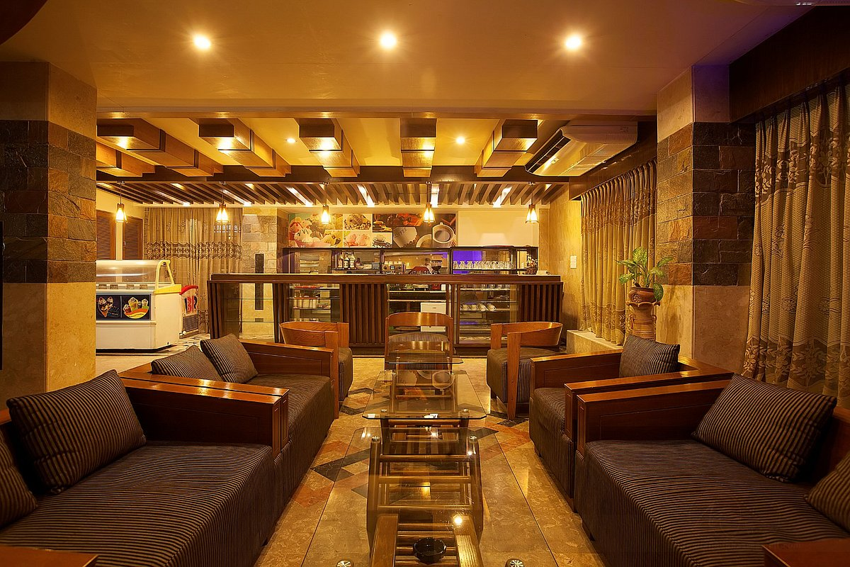

**About Us:**

**Contact Us:**